What is z?

Given a string $s$ of length $n$.

$z_{i}$ is the length of the longest substring starting from $s_{i}$ which is also a prefix of $s$.

General concept

Iterate over $i$.

Maintain an interval $\left[l, r\right]$, which is the interval with maximum $r$ such that $l≤i<r$ and $s_{l\sim r}$ is a prefix-substring.

The algorithm

Suppose we have $\left[l, r\right]$ for $i-1$ $\left(l≤i-1<r→l<i≤r\right)$ and $z_{0} \sim z_{i-1}$.

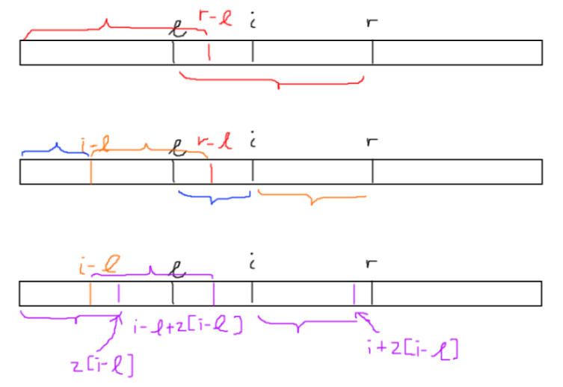if $i>r$, there does not exist any prefix-substring $\left[l, r\right]$ such that $l<i≤r$. Calculate new $z$ value from $l$ naively.

Otherwise, let $k=i-l$.

Since $\left[l,r\right]$ is a prefix-substring, $[0,r-l]=\left[l,r\right]$.

We can divide $\left[l, r\right]$ into $\left[l,i\right]$ and $\left[i,r\right]$, similarly for $\left[0, r-l\right]$. Therefore, $\left[i,r\right]=\left[k,r-l\right]$.

We want to find $z_{i}$, so we can use $z_{k}$ as $\left[i,r\right]=\left[k,r-l\right]$.

2 cases:

$z_{k}<r-i+1$: longest prefix-substring starting from i is length $z_{k}$, no need to update $l,r$

$z_{k}≥r-i+1$: update $l$ to $i$, increment $r$ until $\left[l,r\right]$ is maximum prefix-substring, $z_{i}=r-l$

Linear because $\left[l, r\right]$ is like 2 pointers.

Problem 1: standard pattern matching

Given 2 strings $s$ and $t$ of size $n$ and $m$, find all occurences of $t$ in $s$ as a substring.

Just run z algorithm on the string $s+\#+t$, where # is a character not appearing in $s$ or $t$.

Problem 2: number of distinct substrings

Given a string $s$ of length $n$, find the number of distinct substrings of $s$.

Add $s_{i}$ to $s$ one by one, for each iteration count new substrings formed (that is not already in $s$)

For each iteration, reverse $s$ and do z algorithm on it. Maximum $z_{i}$ is the length of maximum that already exist, so add $length-\max{z_{i}}$ to answer.

Time complexity $O\left(n^{2}\right)$

Can recalculate answer after adding or deleting a character at the end of the string

Problem 3: string compression

Given a string $s$, find the shortest string $t$ such that $t$ concatenated $x$ times ( $x$ can be any number) is equal to $s$.

calculate z function, answer is first $i$ such that $n \% i$ is $0$ and $z_{i}=n-i$

